COMP 354: INTRODUCTION TO SOFTWARE
ENGINEERING

PROJECT MANAGEMENT APPLICATION
SOFTWARE REQUIREMENTS SPECIFICATION

Team B

Alex Huot
Dmitri Novikov
David Gurnsey
Jun Hui Chen
Philip Eloy
Robert Wolfstein
Nicholas Francoeur
Mehdi Jamal Mokhtar
Nivine Shebarou
Lee Kelly
Steven Di Lullo

Tuesday, July 22nd, 2014

Revision History:

Date Created: July 14th, 2014

Most Recent Update: July 22nd, 2014

Previous Updates:

Revision Date | Contributor | Summary
Fill in random date | Fill in some dude's name | Make up some believable riff raff

Table of Contents
Revision History: 2
Document Description: 5
Introduction: 5
Section 1 – UML Class Diagrams and Design Choices: 5
Section 2 – Use Case Sequence Diagrams and Justification: 5
Appendix A 5
Use Case Sequence Diagrams and Justification: 6
Use Case: Create Project 6
Figure 1 - Use Case: Create Project 7
Justification for Create Project 8
Use Case: Add Resource 9
Figure 2 - Use Case: Add Resource 10
Justification for Add Resource 11
Use Case: Generate Gantt Chart 12
Figure 3 - Use Case: Generate Gantt Chart 13
Justification for Generate Gantt Chart 14
References: 15
Appendix A – Iteration 1 Use Cases: 16
Use Case: Create Project <<includes>> Initialize Project Details 16
Use Case: Initialize Project Details 18
Use Case: Edit Project Details 20
Use Case: Create Activity <<includes>> Initialize Activity Details 22
Use Case: Initialize Activity Details 24
Use Case: Add Resource 26
Use Case: Remove Resource 27
Use Case: Edit Cost 28
Use Case: Edit Dependancies 30
Use Case: Generate Critical Path 32
Use Case: Generate Gantt Chart 33
Use Case: Generate PERT Analysis Report 34
Use Case: Generate Earned Value Analysis Report 35
Use Case: View Assigned Activities 36
Business Rules: 40
PERT Analysis Rules: 40
Earned Value Analysis Rules : 43
Glossary: 45
Business Entities: 45

Document Description:

Introduction:
This document provides design documentation for Team B's second iteration deliverable. UML Class diagrams are provided for all software classes. Design-level Sequence Diagrams are provided for 3 selected use cases, alongside a justification for the choice of each case.

Section 1 – UML Class Diagrams and Design Choices:
This section outlines the software's design through UML class diagrams, supported by a description of the design patterns and other design decisions made.

Section 2 – Use Case Sequence Diagrams and Justification:
This section provides UML sequence diagrams based on the Main Success Scenarios of 3 use cases from iteration 1 judged to be architecturally significant. For each sequence diagram, the applicable use case's Main Success Scenario has been provided alongside a justification for the choice of this use case. The chosen use cases have been revised since the last iteration, and these changes are reflected in this document.

Appendix A
All (unchanged) use cases from iteration 1 have been provided in Appendix A for reference, alongside the Glossary and all Business Rules.

Use Case Sequence Diagrams and Justification:

Use Case: Create Project
Successful Outcomes: Primary Actor creates a new Project.

Use Case Package | General Management
ID | UC-GM-01
Use Case Goal | Primary actor successfully creates a new Project.
Actor(s) | Primary Actor: Manager
Level | User-Goal
Precondition | Manager has successfully logged in as per {UC-GF-01}
Domain Entities | Project, Manager

Main Success Scenario:
Step | Action | Notes
1 | Primary Actor indicates intention to create a Project.
2 | System prompts Primary Actor to enter new Project information.
3 | Primary Actor enters Project name and description
4 | System generates a unique Project ID and creates a new Project with the information gathered in Main Success Scenario step 3. Saves and displays the new Project.
5 | Use case ends successfully.

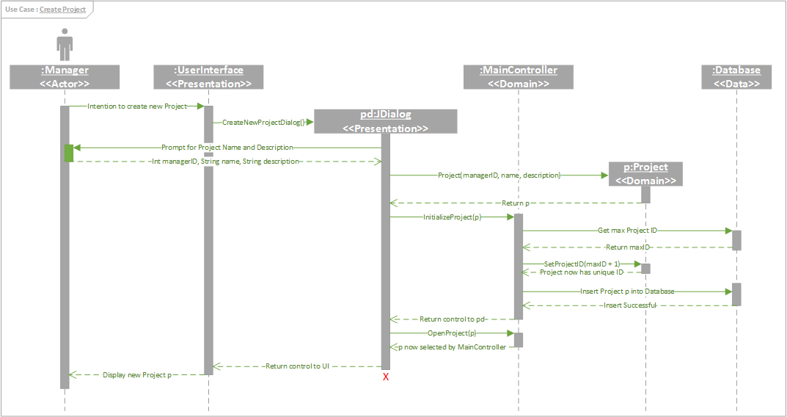
Figure 1 - Use Case: Create Project

Justification for Create Project
Creating projects represents a core functionality of the Project Management Application (PMA), making this use case one of the most significant on a user-goal level. Furthermore, this use case demonstrates how all three architectural layers of the PMA interact, namely the Presentation, Domain Logic and Data Source layers.
In Figure 1, we observe the Presentation layer serves as an interface between the Actor and Domain Logic layer. In other words, the Presentation layer depends on the Domain for all calculations and data representation. In turn, the Domain layer depends on the Database to store all data relationships in a persistent fashion. All projects, activities, members and so on are saved and loaded through the database. In this case we use the database to generate a unique project ID for the new project, after which we can save the project's information in a persistent form.

Use Case: Add Resource
Successful Outcomes: Primary Actor adds a Resource to an Activity.

Use Case Properties:
Use Case Package | Activity Management
ID | UC-AM-03
Use Case Goal | The Primary Actor adds a Resource to the Activity.
Actor(s) | Primary Actor: Manager
Level | User-Goal
Precondition | Primary Actor is a Manager, and the selected Activity has been initialized {UC} and is not completed, and the selected Resource is available.
Domain Entities | Resource, Activity, Manager

Main Success Scenario:
Step | Action | Notes
1 | Primary Actor indicates their intention to add a new Resource to the selected Activity.
2 | System responds by presenting a list of available Resource.
3 | Primary Actor selects a valid Resource from the list.
4 | System prompts Primary Actor for confirmation about the addition of the Resource.
5 | Primary Actor confirms.
6 | Use case ends successfully.

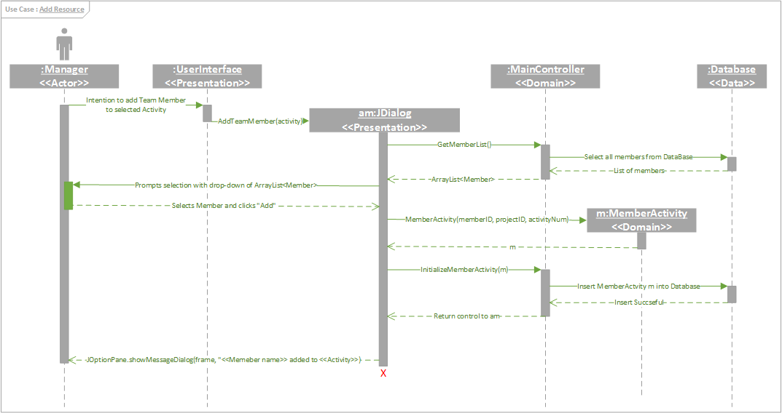
Figure 2 - Use Case: Add Resource

Justification for Add Resource
Managing all aspects of a project, including assigning members (a.k.a. resources) to said project represents another core functionality of the PMA. Thus, this use case is also significant on a user-goal level. Adding a resource also touches all three architectural layers.
In Figure 2, we again observe the Presentation layer managing all interaction between the Actor and Domain. The Domain performs all operations related to creating the Member-Activity association, including fetching member lists from the Database and sending them to the Presentation layer. The new association is then stored in the Database.

Use Case: Generate Gantt Chart
Successful Outcomes: System calculates and displays a visual representation of the Project time table, it's interdependent sequence of Activities.

Use Case Properties:
Use Case Package | Data Analysis
ID | UC-DA-02
Use Case Goal | The Primary Actor has a Gantt Chart compiled and displayed for them.
Actor(s) | Primary Actor: Manager
Level | User-Goal
Precondition | Primary Actor has an active Project with a logically consistent schedule of Activities
Domain Entities | Activities, Manager, Gantt Chart, Project, Critical Path, ES, EF, LS, LF, FLOAT

Main Success Scenario:
Step | Action | Notes
1 | Primary Actor indicates intention to have a Gantt Chart displayed.
2 | System responds calculating the ES, EF, LS, LF, FLOAT, for the Project then generates and displays the Chart.
3 | Use case ends successfully.

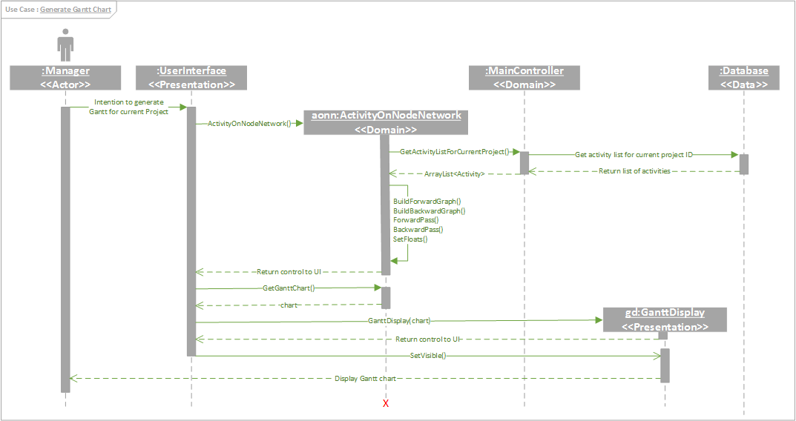
Figure 3 - Use Case: Generate Gantt Chart

Justification for Generate Gantt Chart
Ultimately, the Project Manager will want to use the PMA to make decisions related to the projects they are managing. This is the purpose served by Gantt charts, and thus the generation of such charts represents one of the core uses of the software. Once again, this use case also demonstrates interactions between all architectural layers. Generating these charts requires data and functionality from each layer as can been seen in Figure 3.

References:

Martin Fowler UML Distilled: A Brief Guide to the Standard Object Modelling Language.
Rodger S. Pressman Software Engineering: a Practitioner's Approach
Daniel Sinnig PhD: Lecture Slides, COMP 354
Donald Bell, IBM Corp: UML basics: The sequence diagram

Appendix A – Iteration 1 Use Cases:

Use Case: Create Project <<includes>> Initialize Project Details
Successful Outcomes: Primary Actor creates a new Project.

Use Case Package | General Management
ID | UC-GM-01
Use Case Goal | Primary actor successfully creates a new Project.
Actor(s) | Primary Actor: Manager
Level | User-Goal
Precondition | Manager has successfully logged in as per {UC-GF-01}
Domain Entities | Project, Manager

Main Success Scenario:
Step | Action | Notes
1 | Primary Actor indicates intention to create a Project.
2 | System prompts Primary Actor to enter new Project information.
3 | Primary Actor performs Initialize Project Details.  {UC-PM-01}
4 | System generates a unique Project ID and creates a new Activity with the information gathered inMain Success Scenario step 3. Saves the new Project.
5 | Use case ends successfully.

Alternative Flows:
3a. Initialize Project Details ends unsuccessfully.
Step | Action | Notes
3a.1 | Primary Actor enters information that causes Initialize Project Details {UC-PM-01} to fail.
3a.2 | System returns control to Main Success Scenario Step 2.

3b. Initialize Project Details ends unsuccessfully.
Step | Action | Notes
3b.1 | Primary Actor enters information that causes Initialize Project Details {UC-PM-01} to fail.
3b.2 | User aborts.
3b.2 | Use case ends unsuccessfully.

Use Case: Initialize Project Details
Successful Outcomes: Primary Actor enters the details required to initialize a Project.

Use Case Properties:
Use Case Package | Project Management
ID | UC-PM-01
Use Case Goal | Primary Actor enters valid Project Name, Project Description, Start Date, Target Completion Date, and Budget information required for a new Project.
Actor(s) | Primary Actor: Manager
Level | User-Goal
Precondition | Primary Actor is engaged in Create Project {UC-GM-01} .
Domain Entities | Manager, Project, Start Dat, Target Completion Date, Budget

Main Success Scenario:
Step | Action | Notes
1 | Primary Actor enters Project Name, Project Description, Start Date, Target Completion Date, Budget information.
2 | System verifies the internal consistency of the entered information and prompts the user to confirm.
3 | Primary Actor confirms.
4 | System saves changes to the Project.
5 | Use case ends successfully.

Alternative Flows:
2a. Inconsistent Date Information.
Step | Action | Notes
2a.1 | System informs Primary Actor that the Date information is invalid (e.g. Target Completion Date is before the Start Date or Current Date).
2a.2 | System returns control to Main Success Scenario step 1.

2b. Inconsistent Date Information.
Step | Action | Notes
2b.1 | System informs Primary Actor that the Date information is invalid (e.g. Target Completion Date is before the Start Date or Current Date).
2b.2 | Primary Actor aborts.
2b.3 | Use case ends unsuccessfully.

Use Case: Edit Project Details
Successful Outcomes: Primary Actor updates the details of the existing Project.

Use Case Properties:
Use Case Package | Project Management
ID | UC-PM-02
Use Case Goal | Primary Actor successfully updates any of the following: Project Name, Project Description, Start Date, Target Completion Date, and Budget.
Actor(s) | Primary Actor: Manager
Level | User-Goal
Precondition | Primary Actor has access to their Portfolio as the result of having successfully completed Login{UC-GF-01}.
Domain Entities | Manager, Project, Start Date, Target Completion Date, Budget Portfolio

Main Success Scenario:
Step | Action | Notes
1 | Primary Actor edits any of the following: Project Name, Project Description, Start Date, Target Completion Date, Budget information.
2 | System verifies the internal consistency of the entered information. Then prompts the user to confirm.
3 | Primary Actor confirms.
4 | System saves changes to the Project.
5 | Use case ends successfully.

Alternative Flows:
2a. Inconsistent Date Information.
Step | Action | Notes
2a.1 | System informs Primary Actor that the Date information is invalid (e.g. Target Completion Date is before the Start Date or Current Date).
2a.2 | System returns control to Main Success Scenario step 1.

2b. Inconsistent Date Information.
Step | Action | Notes
2b.1 | System informs Primary Actor that the Date information is invalid (e.g. Target Completion Date is before the Start Date or Current Date).
2b.2 | Primary Actor aborts.
2b.3 | Use case ends unsuccessfully.

Use Case: Create Activity <<includes>> Initialize Activity Details
Successful Outcomes: Primary Actor creates a new Activity.

Use Case Properties:
Use Case Package | Activity Management
ID | UC-AM-01
Use Case Goal | Primary actor successfully creates a new Activity.
Actor(s) | Primary Actor: User
Level | User-Goal
Precondition | Manager is logged in to their Project Portfolio as per Login {UC-GF-01}.
Domain Entities | Activity, Manager, Portfolio, Activity ID

Main Success Scenario:
Step | Action | Notes
1 | Primary Actor indicates intention to create an Activity.
2 | System prompts Primary Actor to enter new Activity information.
3 | Primary Actor performs Initialize Activity Details {UC-AM-02}
4 | System generates a unique Activity ID and creates a new Activity with the information gathered in step 3.
5 | Use case ends successfully.

Alternative Flows:
3a. Initialize Project Details ends unsuccessfully.
Step | Action | Notes
3a.1 | Primary Actor enters information that causes Initialize Activity Details {UC-AM-02} to fail.
3a.2 | System returns control to Main Success Scenario step 1.

3b. Initialize Project Details ends unsuccessfully.
Step | Action | Notes
3b.1 | Primary Actor enters information that causes Initialize Activity Details {UC-AM-02} to fail.
3b.2 | User Aborts.
3b.3 | Use case ends unsuccessfully.

Use Case: Initialize Activity Details
Successful Outcomes: Primary Actor enters the details required to initialize a Activity.

Use Case Properties:
Use Case Package | General Management
ID | UC-AM-02
Use Case Goal | Primary Actor enters valid Activity Name, Activity Description, Start Date, Target Completion Date, and Budget information required for a new Activity.
Actor(s) | Primary Actor: Manager
Level | User-Goal
Precondition | Primary Actor is engaged in Create Activity {UC-AM-01} .
Domain Entities | Manager, Activity, Activity Name, Activity Description, Start Date, Target Completion Date, Budget

Main Success Scenario:
Step | Action | Notes
1 | Primary Actor enters Activity Name, Activity Description, Start Date, Target Completion Date, Budget information.
2 | System verifies the internal consistency of the entered information and prompts the user to confirm.
3 | Primary Actor confirms.
4 | System saves changes to the Activity.
5 | Use case ends successfully.

Alternative Flows:
2a. Inconsistent Date Information.
Step | Action | Notes
2a.1 | System informs Primary Actor that the Date information is invalid (e.g. Target Completion Date is before the Start Date or Current Date).
2a.2 | System returns control to Main Success Scenario step 1.

2b. Inconsistent Date Information.
Step | Action | Notes
2b.1 | System informs Primary Actor that the Date information is invalid (e.g. Target Completion Date is before the Start Date or Current Date).
2b.2 | Primary Actor aborts.
2b.3 | Use case ends unsuccessfully.

Use Case: Add Resource
Successful Outcomes: Primary Actor adds a Resource to an Activity.

Use Case Properties:
Use Case Package | Activity Management
ID | UC-AM-03
Use Case Goal | The Primary Actor adds a Resource to the Activity.
Actor(s) | Primary Actor: Manager
Level | User-Goal
Precondition | Primary Actor is a Manager, and the selected Activity has been initialized {UC} and is not completed, and the selected Resource is available.
Domain Entities | Resource, Activity, Manager

Main Success Scenario:
Step | Action | Notes
1 | Primary Actor indicates their intention to add a new Resource to the selected Activity.
2 | System responds by presenting a list of available Resources.
3 | Primary Actor selects a valid Resource from the list.
4 | System prompts Primary Actor for confirmation about the addition of the Resource.
5 | Primary Actor confirms.
6 | Use case ends successfully.

Use Case: Remove Resource
Successful Outcomes: Primary Actor removes a Resource from an Activity.

Use Case Properties:
Use Case Package | Activity Management
ID | UC-AM-04
Use Case Goal | The Primary Actor removes a Resource from the Activity.
Actor(s) | Primary Actor: Manager
Level | User-Goal
Precondition | Primary Actor is a Manager, that the selected Activity has been initialized {UC} and is not completed, and the selected Resource is assigned to the selected Activity.
Domain Entities | Resource, Activity, Manager

Main Success Scenario:
Step | Action | Notes
1 | Primary Actor indicates intention remove a specific Resource from the selected Activity.
2 | System responds by presenting the list of assigned Resources for the Activity.
3 | Primary Actor selects a Resource from the list.
4 | System prompts Primary Actor for confirmation about the removal of the Resource.
5 | Primary Actor confirms.
6 | Use case ends successfully.

Use Case: Edit Cost
Successful Outcomes: Primary Actor updates the Cost information for the selected Activity.

Use Case Properties:
Use Case Package | Activity Management
ID | UC-AM-05
Use Case Goal | Primary User successfully edits any of the following Activity values: AC.
Actor(s) | Primary Actor: Manager
Level | User-Goal
Precondition | The Primary Actor has at least one active Activity in the current Project.
Domain Entities | Activity, Manager, AC.

Main Success Scenario:
Step | Action | Notes
1 | Primary Actor indicates intention to edit the AC value of the Activity.
2 | System validates correctness of new data values and prompts the Primary Actor to confirm the update.
3 | User confirms.
4 | Use case ends successfully.

Alternative Flows:
4a. Invalid entry.
Step | Action | Notes
4a.1 | Data entered by the Primary Actor fails consistency check (i.e. Wrong data type, negative value ...).
4a.2 | System informs Primary Actor of the error and prompts re-try.
4a.3 | Use case resumes at Main Success Scenario step 1.

4b. Invalid entry.
Step | Action | Notes
4b.1 | Data entered by the Primary Actor fails consistency check (i.e. Wrong data type, negative value ...).
4b.2 | System informs Primary Actor of the error and prompts re-try.
4a.3 | User aborts.
4a.4 | Use ends unsuccessfully.

Use Case: Edit Dependancies
Successful Outcomes: The list of Activities that the currently selected Activity depends on is updated to reflect the correct sequence of the Project.

Use Case Properties:
Use Case Package | Activity Management
ID | UC-AM-06
Use Case Goal | Primary Actor updates list of preceding Activities.
Actor(s) | Primary Actor: Manager
Level | User-Goal
Precondition | The Primary Actor is a Manager and has at least 2 Activities that are active in the current Project.
Domain Entities | Manager, Project, Activity

Main Success Scenario:
Step | Action | Notes
1 | Primary Actor selects an Activity whose dependancy information will be updated.
2 | System responds by presenting the dependancy information of the Activity.
3 | Primary Actor makes the change to the dependancy information.
4 | System verifies that the update is valid and prompts the Primary Actor to confirm.
5 | Primary Actor confirms the change.
6 | Use case ends successfully.

Alternative Flows:
4a. Invalid update.
Step | Action | Notes
4a.1 | Verification of the update fails and the System informs the user of the error and prompts a retry.
4a.2 | System returns control to Main Success Scenario step 3.

4b. Invalid update.
Step | Action | Notes
4b.1 | Verification of the update fails and the System informs the user of the error and prompts a retry.
4b.2 | Primary Actor aborts.
4b.3 | Use Case ends unsuccessfully.

6a. Primary has more changes to make.
Step | Action | Notes
6a.1 | Primary Actor indicates intention to make more changes.
6a.2 | System returns control to Main Success Scenario step 1.

Use Case: Generate Critical Path
Successful Outcomes: System calculates and displays a visual representation of the Project time table, it's interdependent sequence of Activities as an Activity on Node with the Critical Path highlighted.

Use Case Properties:
Use Case Package | Data Analysis
ID | UC-DA-01
Use Case Goal | The Primary Actor has a Activity on Node compiled and displayed for them with the Critical Path highlighted.
Actor(s) | Primary Actor: Manager
Level | User-Goal
Precondition | Primary Actor has an active Project with a logically consistent schedule of Activities
Domain Entities | Activities, Manager, Activity on Node, Project, Critical Path, ES, EF, LS, LF, FLOAT

Main Success Scenario:
Step | Action | Notes
1 | Primary Actor indicates intention to have a Gantt Chart displayed.
2 | System responds calculating the ES, EF, LS, LF, FLOAT for the Project then generates and displays the Chart.
3 | Use case ends successfully.

Use Case: Generate Gantt Chart
Successful Outcomes: System calculates and displays a visual representation of the Project time table, it's interdependent sequence of Activities.

Use Case Properties:
Use Case Package | Data Analysis
ID | UC-DA-02
Use Case Goal | The Primary Actor has a Gantt Chart compiled and displayed for them.
Actor(s) | Primary Actor: Manager
Level | User-Goal
Precondition | Primary Actor has an active Project with a logically consistent schedule of Activities
Domain Entities | Activities, Manager, Gantt Chart, Project, Critical Path, ES, EF, LS, LF, FLOAT

Main Success Scenario:
Step | Action | Notes
1 | Primary Actor indicates intention to have a Gantt Chart displayed.
2 | System responds calculating the ES, EF, LS, LF, FLOAT, for the Project then generates and displays the Chart.
3 | Use case ends successfully.

Use Case: Generate PERT Analysis Report
Successful Outcomes: System calculates and displays a visual representation of the important metrics associated with the Project complete with a probabilistic assessment of the likelihood of it finishing on time and on budget respectively.

Use Case Properties:
Use Case Package | Data Analysis
ID | UC-DA-03
Use Case Goal | The Primary Actor has a PERT Analysis Report compiled and displayed for them.
Actor(s) | Primary Actor: Manager
Level | User-Goal
Precondition | Primary Actor has an active Project with a logically consistent schedule of Activities
Domain Entities | Activities, Manager, PERT Analysis

Main Success Scenario:
Step | Action | Notes
1 | Primary Actor indicates intention to have a PERT Analysis Report displayed.
2 | System responds by calculating the relevant values for the Project then generates and displays the a report.
3 | Use case ends successfully.

Use Case: Generate Earned Value Analysis Report
Successful Outcomes: System calculates and displays a visual representation of the important metrics associated with a Project complete with a probabilistic assessment of the likelihood of it finishing on time and on budget respectively.

Use Case Properties:
Use Case Package | Data Analysis
ID | UC-DA-04
Use Case Goal | The Primary Actor has a Earned Value Report compiled and displayed for them.
Actor(s) | Primary Actor: Manager
Level | User-Goal
Precondition | Primary Actor has an active Project with a logically consistent schedule of Activities
Domain Entities | Activities, Manager, Activity on Node, Earned Value

Main Success Scenario:
Step | Action | Notes
1 | Primary Actor indicates intention to have a Earned Value Report displayed.
2 | System responds by calculating the relevant values for the Project then generates and displays the a report.
3 | Use case ends successfully.

Use Case: View Assigned Activities
Successful Outcomes: Primary Actor accesses descriptions and deadline information of Activities' assigned to them.

Use Case Properties:
Use Case Package | Team Member
ID | UC-TM-01
Use Case Goal | The Primary Actor accesses the details of the Activities assigned to them.
Actor(s) | Primary Actor: Team Member
Level | User-Goal
Precondition | Primary Actor has successfully logged in to their Portfolio {UC-GF-01} and Primary Actor has at least assigned Activity.
Domain Entities | Team Member, Activity, Portfolio

Main Success Scenario:
Step | Action | Notes
1 | Primary Actor selects an Activity to investigate from the list of all Activities assigned to them.
2 | System responds by presenting the details of the selected Activity.
3 | Primary Actor reviews information.
4 | Use case ends successfully.

Alternative Flows:

4a. Primary Actor investigates another Activity.
Step | Action | Notes
4a.1 | Primary Actor wishes to continue viewing Activities.
4a.2 | Use case restarts at step 1.

Use Case: Login
Successful Outcomes: Primary Actor accesses their appropriate Portfolio.

Use Case Properties:
Use Case Package | Global Functionality
ID | UC-GF-01
Use Case Goal | Primary Actor gains access to their Portfolio
Actor(s) | Primary Actor: User
Level | User-Goal
Precondition | User has launched the PMA
Domain Entities | PMA, Portfolio

Main Success Scenario:
Step | Action | Notes
1 | Primary Actor indicates intention to log in to Portfolio.
2 | System prompts Primary Actor for ID and Password.
3 | Primary Actor supplies login information.
4 | System verifies the Primary Actor and presents them with their Portfolio appropriate to their User type (i.e. Team Member or Manager).
5 | Use case ends successfully.

Alternative Flows:
4a. Unrecognized User.
Step | Action | Notes
4a.1 | System finds no matching ID and Password combination.
4a.2 | Returns to Main Success Scenario step 2.

4b. Unrecognized User.
Step | Action | Notes
4b.1 | System finds no matching ID and Password combination.
4b.2 | User aborts the program.
4b.3 | Returns to Main Success Scenario step 2.

Business Rules:

PERT Analysis Rules:
Number | Label | PERT Analysis Rule | Calculation | Notes
PR01 | ES – Earliest Start | The earliest time at which an Activity can start given that its preceding Activities must finish first. | MAX (Latest Finish) of preceding Activities
PR02 | EF – Earliest Finish | The Activity's earliest start plus its duration. | ES + D
PR03 | LF – Latest Finish | Latest time the Activity can finish without delaying the entire Project. | Calculated during the backwards pass.
PR04 | LS – Latest Start | Latest finish time minus the duration. | LF - D
PR05 | D - Duration | Length of time to complete the Activity.
PR06 | F - Float | Degree of flexibility for the duration of the Activity without effecting the Critical Path.
PR07 | CP – Critical Path | The sequence of Activities, that if any one were to be delayed, the Project would also be delayed.
PR08 | m – Most likely Time to Completion | Best guess at the remaining time to complete the Activity. Subject to revision.
PR09 | a – Optimistic Time to Completion | Wishful estimate of time to complete the Activity.
PR10 | b – Pessimistic Time to Completion | Pessimistic estimate of time to complete the Activity.
PR11 | T – Target Date of Completion | Manager set due date for a project.
PR12 | t – Expected Duration | Estimated duration of the task. | (a+4m+b) ÷ 6
PR13 | z - z-score | Calculated value, to be compared against a table to return a probability. | (b - a) ÷ 6
PR14 | P – Probability of meeting Target Date of Completion | End result of the | Found from the z-score lookup table.
PR15 | FPR – Forward Pass Rule | Used to determine the ES and EF of each Node in the Network. The rule sweeps forward through the Network, updating the values of each Node. | The ES of a given Node n is the MAX(LS) of all preceding Nodes upon which n depends.
PR16 | BPR – Backwards Pass Rule | Used to determine the LS and LF of each Node in the Network. The rule sweeps backward through the Network, updating the values of each Node. | The LF of a given Node n is the MIN(LS) of all preceding (backward pass) Nodes.

Earned Value Analysis Rules :
Number | Label | Earned Value Rule | Calculation | Notes
EV01 | PV - Planned Value (Project) | Sum of PVs of Activities in the Project. | Sum (PV_{k}) for all tasks k.
EV02 | PV - Planned Value (Activity) | Budget planned for the Activity based on the projected Resource costs. | Estimated by Manager.
EV03 | EV - Earned Value | Sum of PVs of Activities in the Project that have been completed at the time of analysis. | Sum (PV_{k}) for all tasks k that have been completed. | Uses the Percentage Technique
EV04 | BAC – Budget at Completion | Sum of PVs of Activities in the Project that remain | Sum (PV_{k}) for all tasks k.
EV05 | PSC – Percent Scheduled for Completion | Measure of the amount of work that should be done by a certain time given the Project's estimates. | PV(Project) ÷ BAC
EV06 | AC – Actual Cost (Project) | Actual tally of expenditures incurred by completed Activities. | Sum (Debts against Completed Activities)
EV06 | AC – Actual Cost (Activity) | Expenditures incurred by the Activity.
EV07 | PC - Percent Complete | Percentage of the Project completed at a given time. | EV ÷ BAC
EV08 | CV – Cost Variance | Difference between what should have been paid for completed work and what actually was paid for that work. | EV - AC
EV09 | SV – Schedule Variance | Difference between the value of completed work and value of the planned work. | EV - PV
EV10 | CPI – Cost Performance Index | Earned Value over Actual Cost. Values over 1 indicate the cost has been less than projected. | EV ÷ AC
EV11 | SPI – Schedule Performance Index | Earned Value over Planned value. Values over 1 indicate the Project is ahead of schedule. | EV ÷ PV
EV12 | EAC – Estimate at Completion | Indicates the projected cost of the Project at completion. | BAC ÷ CPI
EV13 | ETC – Estimate to Completion | Indicates projected cost overrun or underrun. | EAC - AC

Glossary:

Business Entities:
Business Entity | Description
PMA | Project Management Application.
Project Manager | An application user with the abilities to create and manage projects and activities.
Team Member | An application user to whom activities are assigned.
Project Portfolio | A collection of projects.
Activity Portfolio | A collection of activities.
Resource | Another term for a team member.
Project | A collection of ordered activities.
Activity | A task to be completed in the larger setting of a project.
Project ID | A unique identifier for a project.
Activity ID | A unique identifier for an activity.
Project Name | A name chosen by the manager for their project.
Activity Name | A name chosen by the manager for their activity.
Project Description | A description given by the manager for their project.
Activity Description | A description given by the manager for their activity.
Cost | The actual monetary expenditure of an activity or project.
Schedule | The sequence of activities required to complete a project. These activities each have projected durations allowing the project to gauge wether it is progressing on target or not.
Critical Path | The sequence of activities for which if any one finishes later than their latest finish, the entire project will be delayed.
Gantt Chart | A visual depiction of the dependency driven schedule of a project.
PERT Analysis | A complex analysis tool for projecting project cost overruns and schedule delays. More information can be found here.
Earned Value Analysis | A tool for measuring the progression of a project throughout its execution. More information can be found here.
Activity on Node Graph | A visual representation of the dependancy chain of activities in a project.

